TA6255 Prototype ESB Service Management and Monitoring in Mule based on the design in US2855, US2992, and TA5815

# ESB logging and url based routing flow

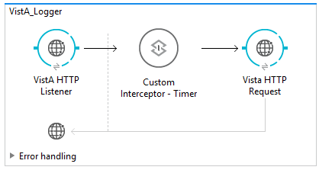

## Prototype

This flow demonstrates an ESB endpoint which accepts a url and then forwards the request to a specified endpoint

Limitations: The flow does not support https.

## Custom Interceptor

The ESB Monitoring and Reporting document attached to this use story has a discussion of options for getting the http:request responseTime. It turns out that the custom java code executes after the flow, so the ability to <wiretap/> or <async/> then both will not have access. The HttpAppender log4j2 Appender fails to be recognized by mule, so there is no good way to send the responseTime() to a log using a flow component. Therefore we are demonstrating posting the responseTime() from the java code.

### Input JSON

(none)

## Config

mule-app.properties config

### inbound port; use this for cloudhub deployments as well

listener.host:0.0.0.0

http.port:8086

### target REST API server port

#request.host:aws-vista.mccf.halfakerlabs.com

#request.port:9080

request.host:localhost

request.port:8193

### target REST API http header settings

request.header.x.key:12345

request.header.x.userid:user01x

### MUnit settings

munit.test.http.request.uri:/api/v1/menus

## Error handling

Limitations: The HTTP does not trap Connection Refused and http.status error conditions.

Limitations: HTTP_Request_Configuration_Dynamic is not set

## munit tests

<https://bitbucket.org/halfaker/mccf_esb_vista_logger/src/fa36a337bc50ae7c01612a99d9523406fd98c566/src/test/munit/vista-logger-test.xml?at=master&fileviewer=file-view-default>

<https://bitbucket.org/halfaker/mccf_esb_vista_logger/src/fa36a337bc50ae7c01612a99d9523406fd98c566/src/test/munit/vista-logger-404-test.xml?at=master&fileviewer=file-view-default>

The munit test in the flow depicted below calls the http:request endpoint and returns 200

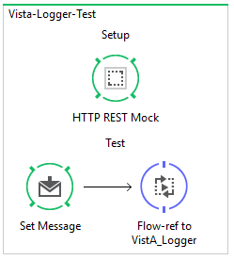

The munit test in the flow depicted below mocks http status code of 404 returned from the http:request endpoint.

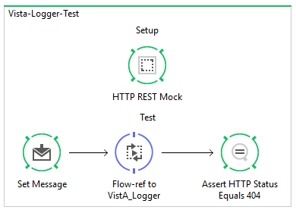

## Building

**Turns out that we need mule_ee jars.**

**1) Anypoint appears to download these for you - right click on the mule project Mule → Populate Maven Repository**

**2) alternatively we need an enterprise license and set the credentials in the settings.html, per**[**https://docs.mulesoft.com/mule-user-guide/v/3.9/using-maven-with-mule**](https://docs.mulesoft.com/mule-user-guide/v/3.9/using-maven-with-mule)

**This won't work without one of the two above.**

$git clone <https://bitbucket.org/halfaker/mccf_esb_va_fhir_server>

or

$git clone <https://bitbucket.org/halfaker/mccf_esb_vista_logger>

change your mvn settings.xml to use the halfaker repo. A settings file is in the $mccf_esb_vista_logger repo, mvn directory -- $mccf_esb_vista_logger/mvn/settings.xml

$cd into either and then run the following mvn to see that the work

$mvn clean package -DskipMunitTests  // packages vistalogger-1.0.0-SNAPSHOT.zip

$mvn clean test